1st Annual DMHA Co-Ed
Slo-Pitch Tournament

Dorchester Community Park Diamonds
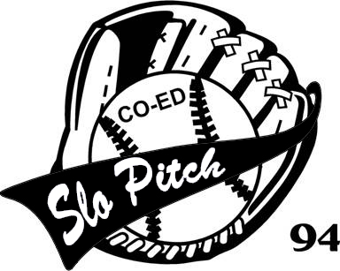
Saturday June 10th, 2017

Registration Fee $500.00/team
Minimum of 10 players
Equal number of men and
women per team
Guaranteed 3 Games

Come out and have some fun while supporting the Dorchester Minor Hockey Association

Contact Cathy at cathy_zantingh@yahoo.ca or call 519-694-5350 to reserve your spot today!

