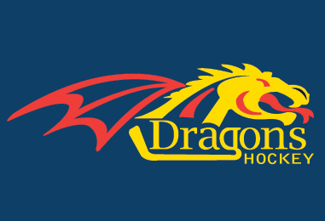

2015 POWER SKATING/GOALIE CLINICS

DMHA will again hold power skating clinics in Dorchester for this season. Each clinic will require a minimum enrolment (see below) in order to offer the program. If you have any questions, please contact Jeff Morrison at jdmorrison31@gmail.com.
Tyke/Novice (5-6 pm). Cost is $90.00 per player for all 8 sessions. A minimum of 20 skaters will be required to offer this clinic. The instructor will be Mike Cormier. The clinics will be held on the following dates:
- October 19,26
- November 16,23
- December 14, 21
- January, 11,18
Atom/Pee-Wee (6-7 pm). Cost is $100.00 per player for all 8 sessions. A minimum of 30 skaters will be required to offer this clinic. The instructor will be Mike Ellis of Progressive Hockey Development. The dates will be as follows:
- October 19,26
- November, 2,9,6,23,30
- December 7
DMHA is also determining if there is interest in a goalie clinic. A minimum of 10 goalies will be required to offer the clinic. 6 sessions are proposed at a cost of $125.00 per goalie. The instructor will be Paul Gibson of Progressive Hockey Development. The dates (5-6 pm) will be as follows.
- Nov 2,9,30
- Dec 7
- Jan 4, 25 (alternate to December 28)
Players Name:_______________________________________
Date Of Birth:_______________________________________
Team:_____________________________________________
Guardian Name:_____________________________________
Address:___________________________________________
City/Town:_________________________________________
Postal Code:________________________________________
Phone Number:_____________________________________
Doctor’s Name:_____________________________________
Doctor’s Phone Number:_____________________________
Method of Payment: Cash or cheque?
Registrants and their families are subject to the DMHA constitution, OMHA by-laws and code of conduct. Cheques are to be made payable to Dorchester Minor Hockey Association. NSF cheques will carry a $35.00 penalty and your child will not be allowed to continue until full payment is made. Dorchester Minor Hockey Association collects your personal information so that we may fulfill our responsibilities of providing hockey programs in a cost efficient manner. Your personal information will be used by the Dorchester Minor Hockey Association for its programs. Dorchester Minor Hockey Association will not sell your personal information to anyone.
Guardian’s Signature:______________________________________________
Signing the above relinquishes responsibility from DMHA for any injury that may occur.

